

**Evaluation of Git Integration For JIRA**

No : TD/QSTE/DC/01

Ver : 0.1

4-Jan-2021

|  |  |  |  |  |
| --- | --- | --- | --- | --- |
|  |  |  | Initials | Sign & Date |
|  |  | Prepared by | NT | 4-Jan-2020 |
|  |  | Approved by |  |  |

Company Internal.

**Tata Elxsi**

# Revision History

|  |  |  |  |
| --- | --- | --- | --- |
| **Rev. No** | **Approved Date** | **Affected/ Sections Pages** | **Description** |
| 0.1 | 4-Jan-2020 | All | Initial draft version |
|  |  |  |  |

# Contents

1. Revision History 2

2. Contents 3

3. Introduction 4

3.1 Purpose and scope 4

4. Evaluation Steps 5

4.1 Enable Git Integration for Jira 5

4.2 GIT JIRA linking 7

4.3 Linking commits with different type of files 11

4.4 Compare Code 13

4.5 Jira User Information Card 15

4.6 Git Roll Up 16

4.7 Access Management 17

4.7.1 Git Repository Access Management 18

4.8 Features not supported in Gerrit 21

4.8.1 21

# Introduction

## Purpose and scope

The Git Integration for Jira open in new tab app is intended for displaying list of commits linked with a particular Jira issue. It is often useful to figure out real issue progress as well as contributors involved in the real work of an issue.

# Evaluation Steps

## Enable Git Integration for Jira

* Enabled the plugin with trial license using JIRA Admin rights.

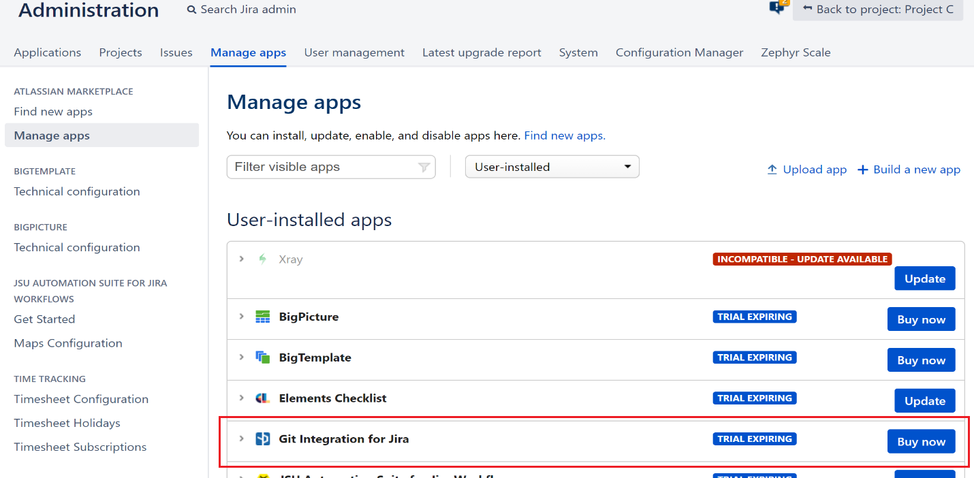

* Admin options got enabled in “Applications” Tab. Plugin level configurations possible using “general Settings” option.

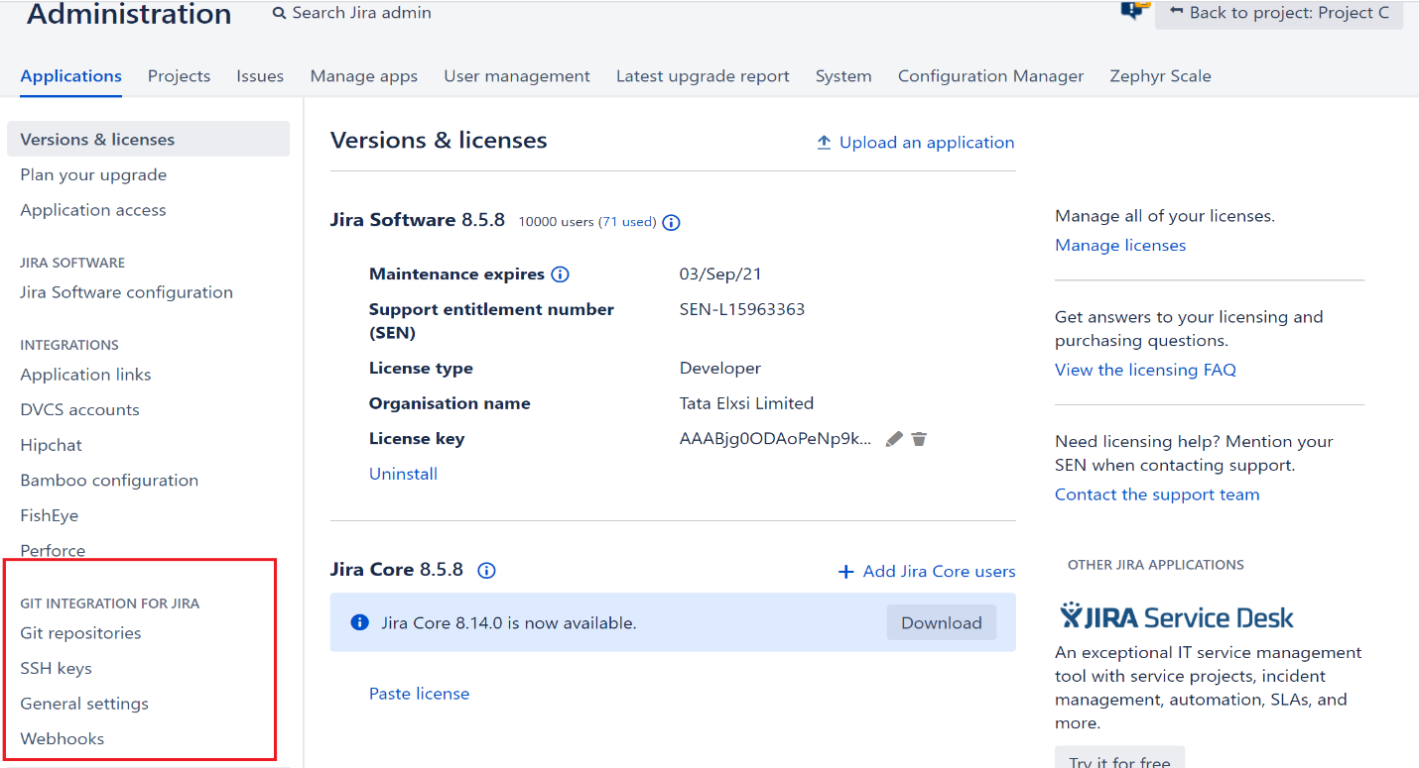

* Git repository can be linked using “Git repositories” option. Click on “Connect to Git Repository” to enter repository URL, user name & password.

TE_GIT_JIRA git repository is connected to the plugin for trial purpose.

“Reindex repository” option can be used to sync between git server & JIRA to update the latest commits. By default, auto-sync is performed every 5 minutes. This can be configured.

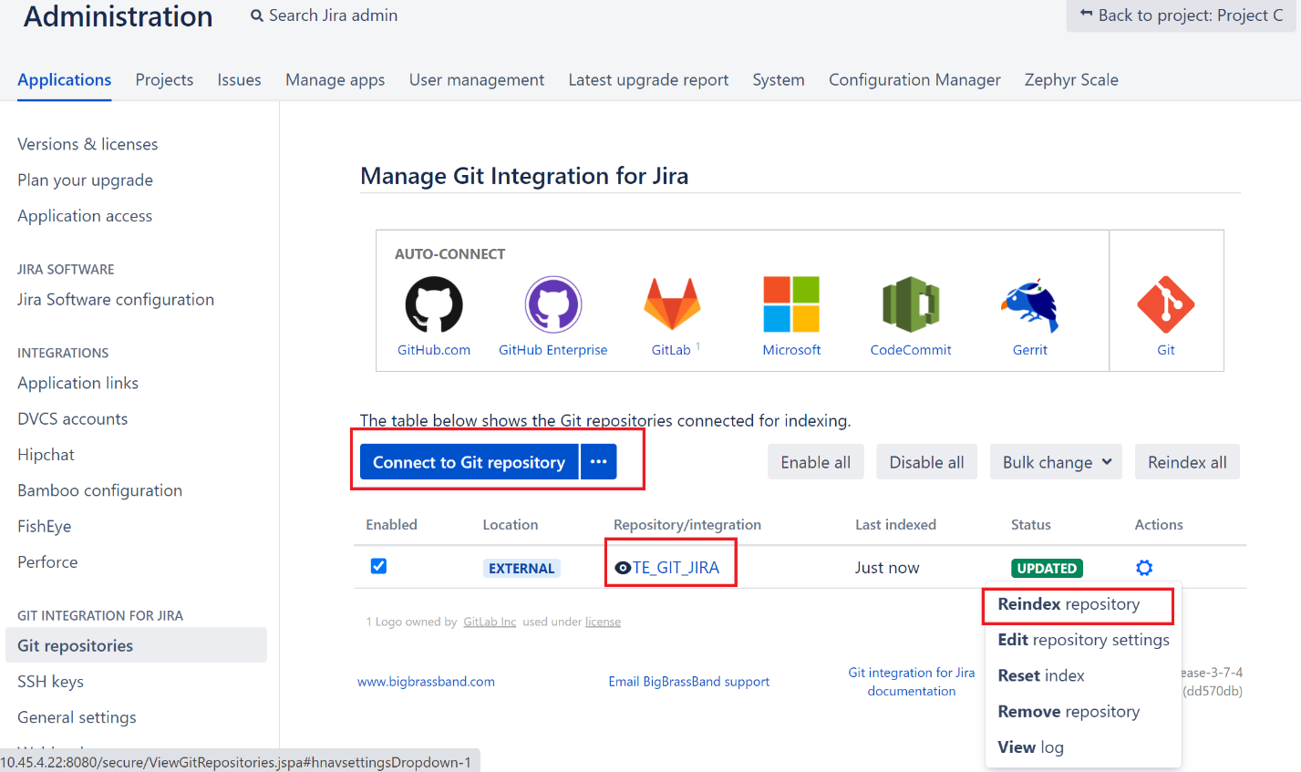

* “Edit repository settings” can be use to configure repository specific settings like enable/disable Smart commits, Source Code Diff viewing, Project level access restriction etc.

## GIT JIRA linking

* Git commits can be linked with any JIRA ticket by providing the ticket ID in commit message,

Any tickets which are not linked using git commit window can be linked from Git – Commits window.

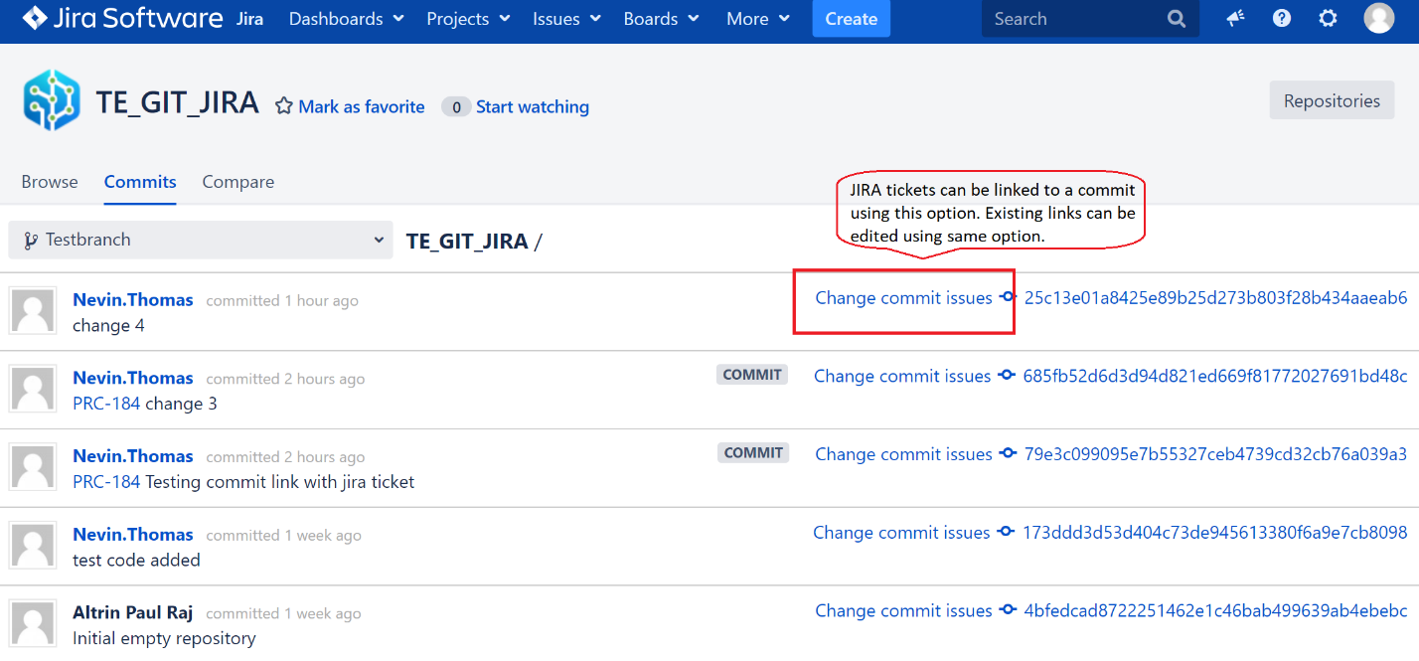

* All the commits get auto synced for all the branches as per the configured time & will be available in the above window.
* **Smart Commits**

Multiple actions are possible using a syntax from git commit window, in addition to the JIRA ID linking.

Below example shows adding JIRA comment using #comment keyword & logging work log using #time syntax.

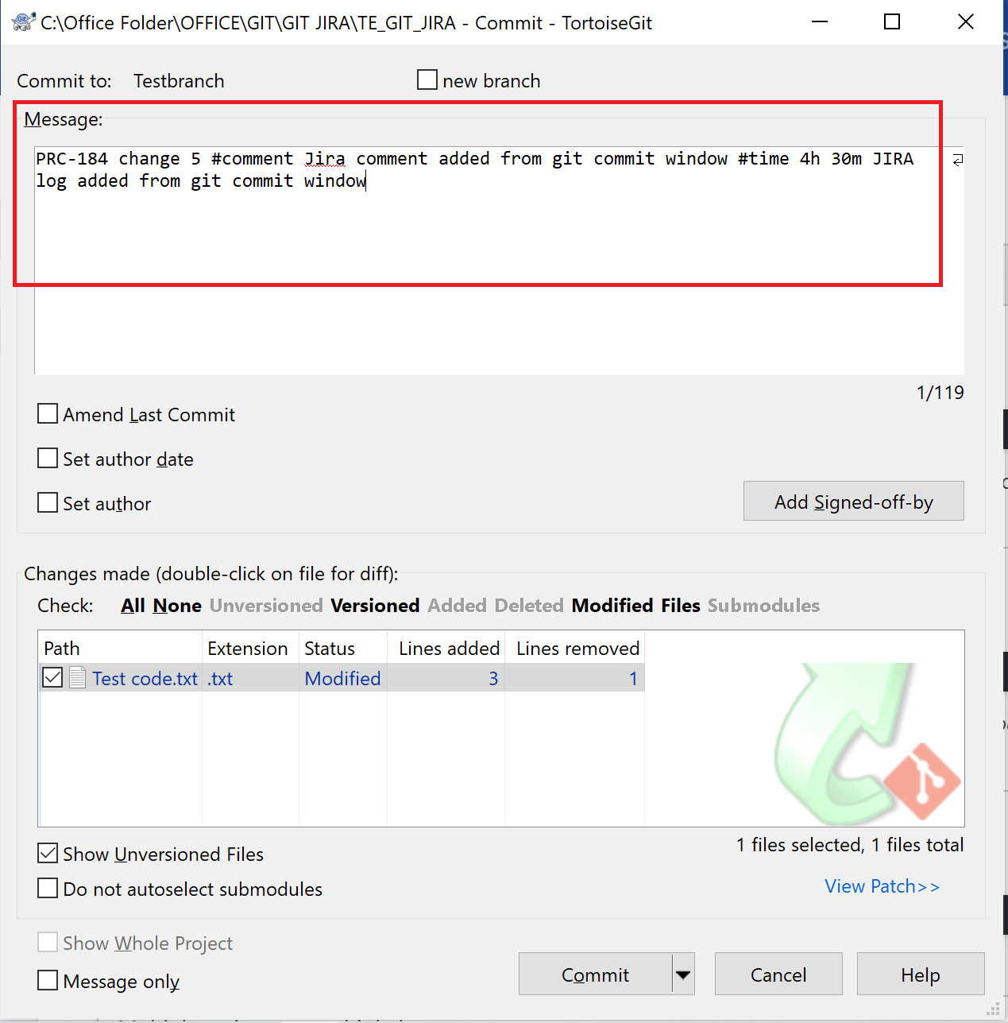

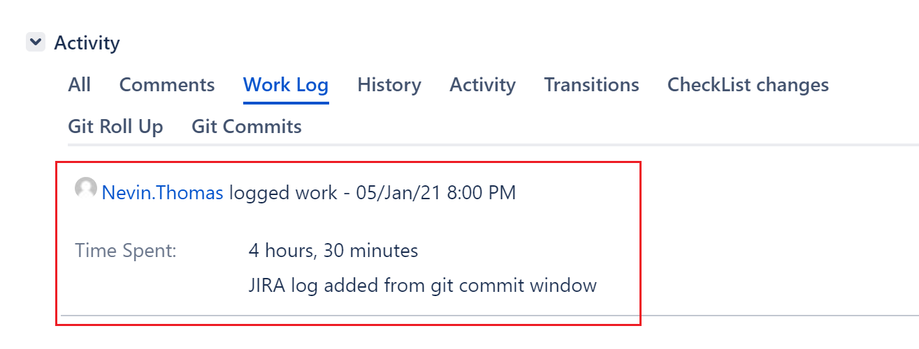

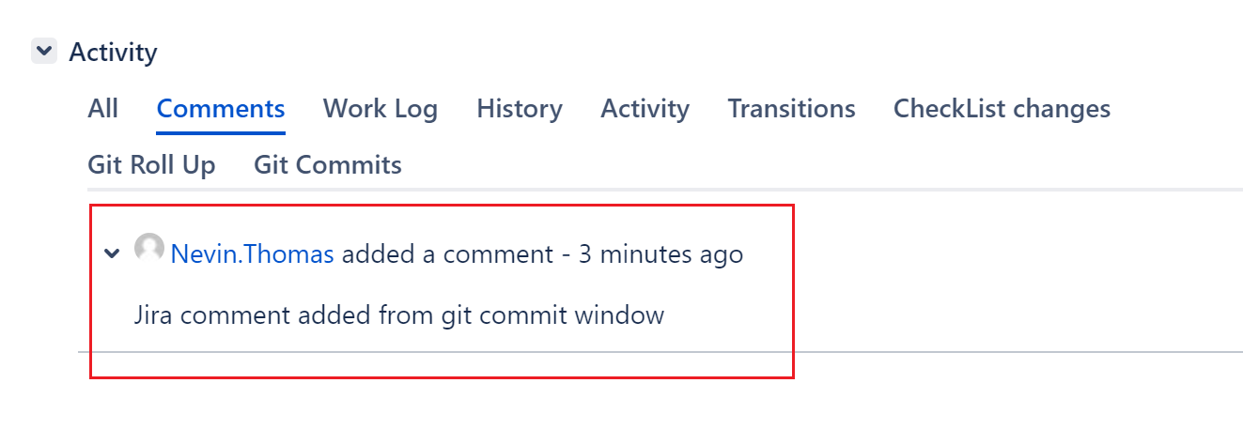

* Below options can also be done from git commit window:
* Changing the ticket status #<transition-name> - E.g.: #close, #code-review

https://bigbrassband.com/git-integration-for-jira/documentation/smart-commits.html#sc_wkflow

* Filling JIRA field values #fixversion [project version], #label [label1] etc.
* Adding assignee: #assign [<Jira username> or <email of Jira user>]

**Smart commits: Different Scenarios**

* **Case 1:** Changing to a status which is not possible as per the workflow

Commit message: PRC-184 Testing ticket status change #close Closing the ticket

Commit was linked to the JIRA ticket with a smart commit error warning as below:

Status transition did not happen but work log was successful.

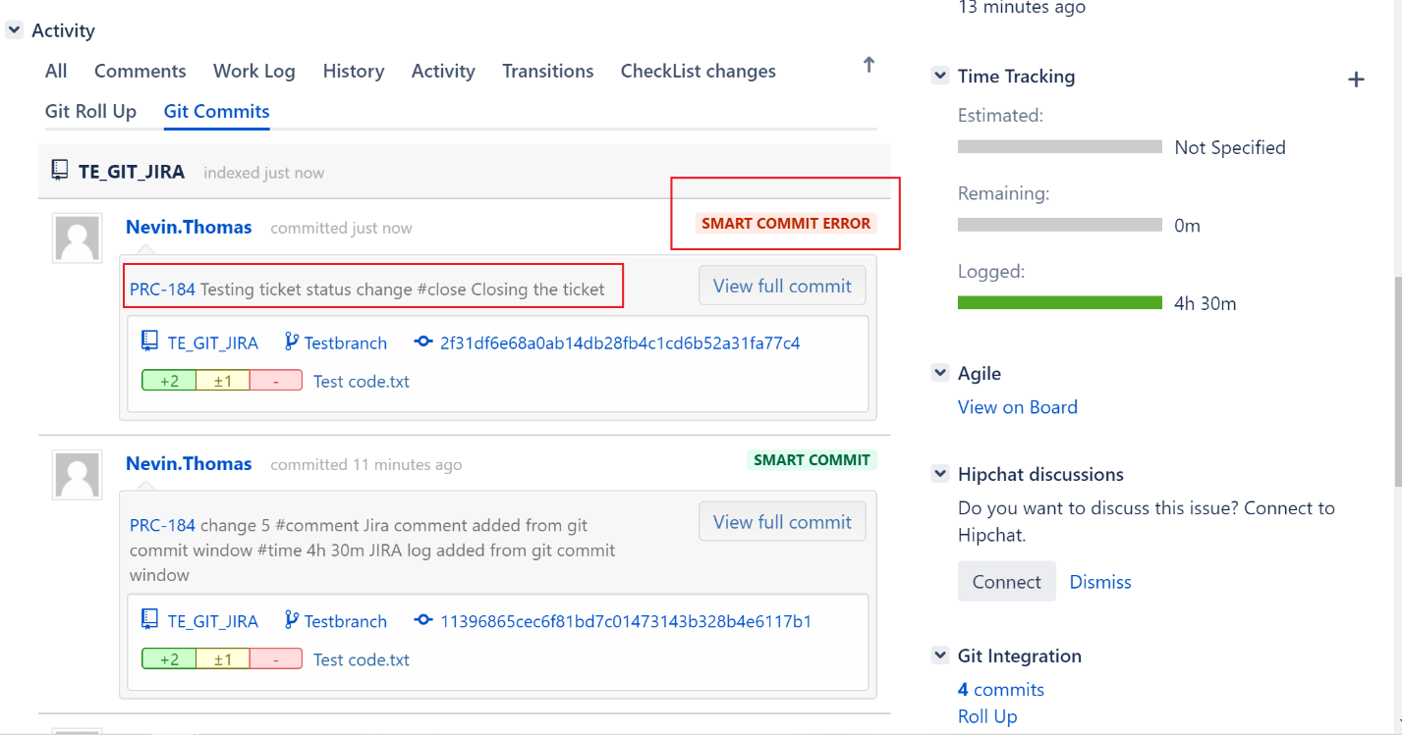

* **Case 2:** Changing to In progress status, which is a possible transition as per the workflow.

Commit message: PRC-184 testing JIRA status change #in-progress moving to in

Commit was linked to the JIRA ticket & the ticket status moved to “In Progress”

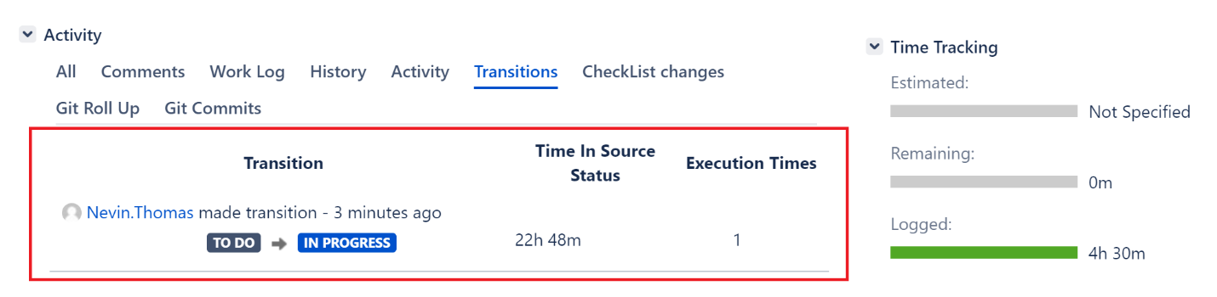

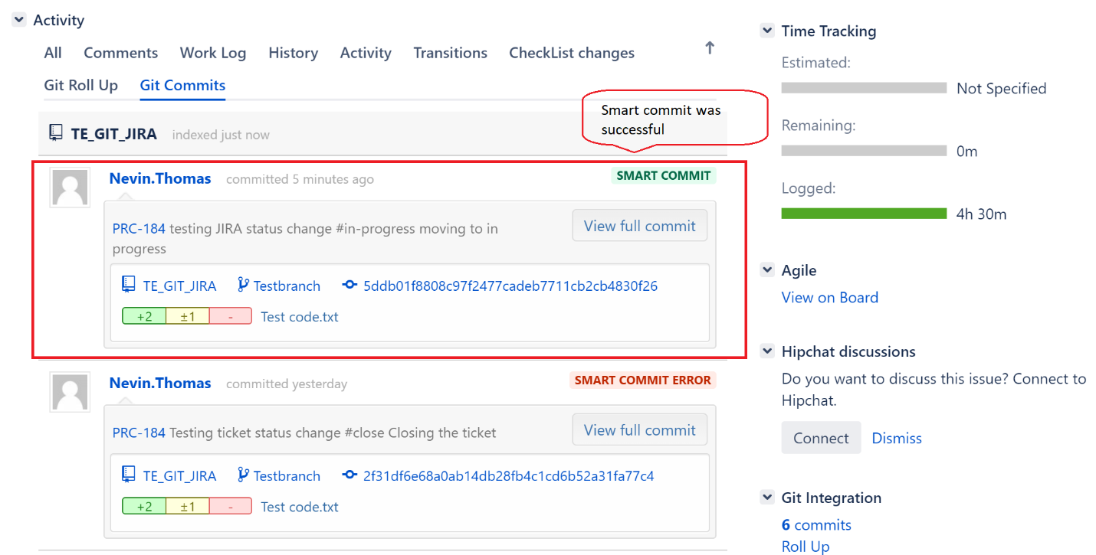

## Linking commits with different type of files

* Excel & text files are visible in commits & browser tabs. There is no option to download or view excel file contents.

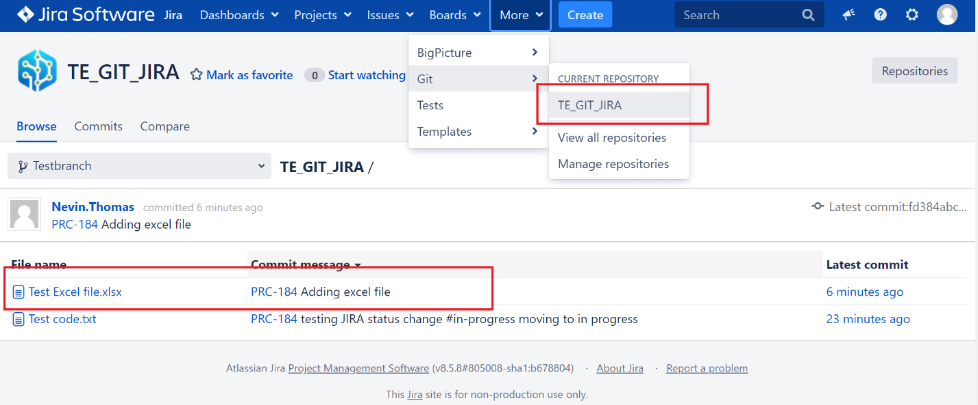

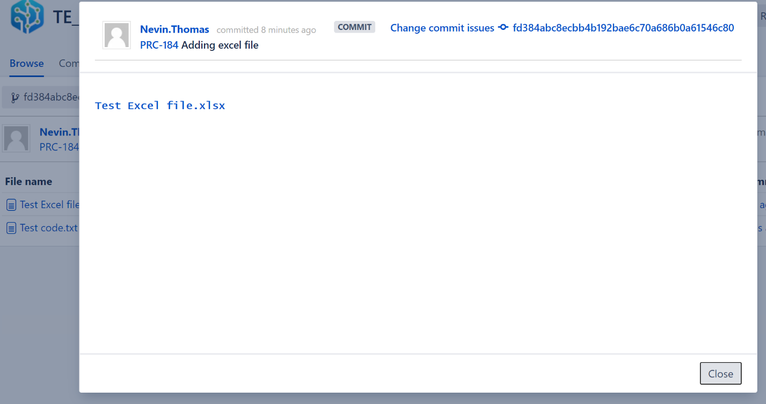

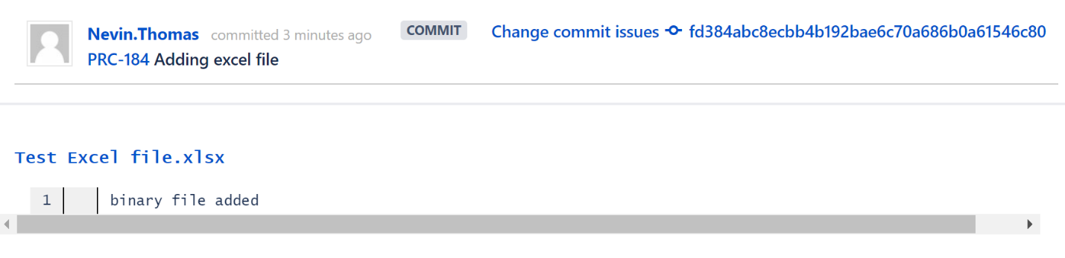

## Compare Code

* Diff operation can be performed between same files in different branches (which file content change)
* Click on “Compare code” within JIRA ticket.

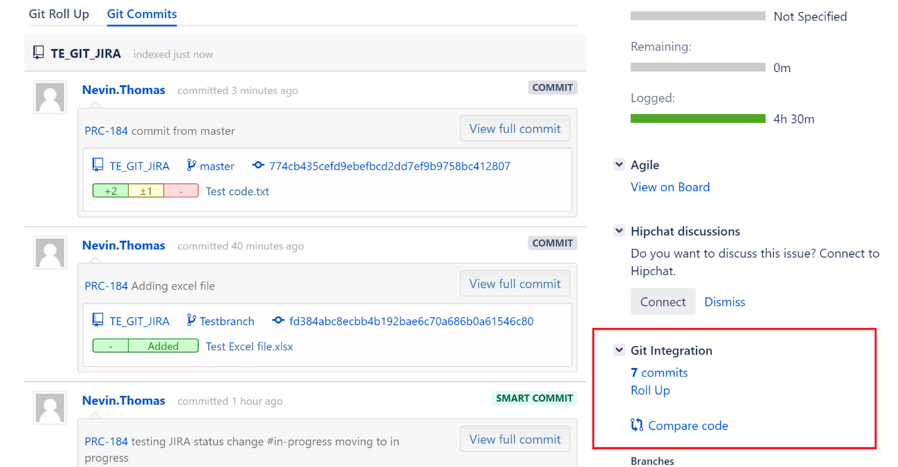

* GIT compare window opens up. Select the branches to compare.

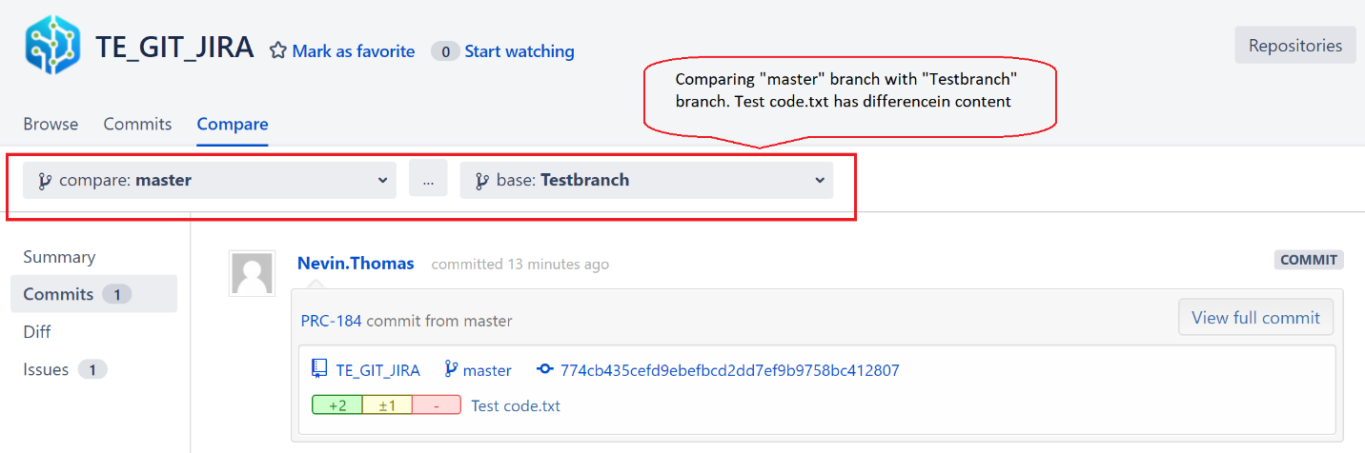

* File differences are visible in “Diff” tab

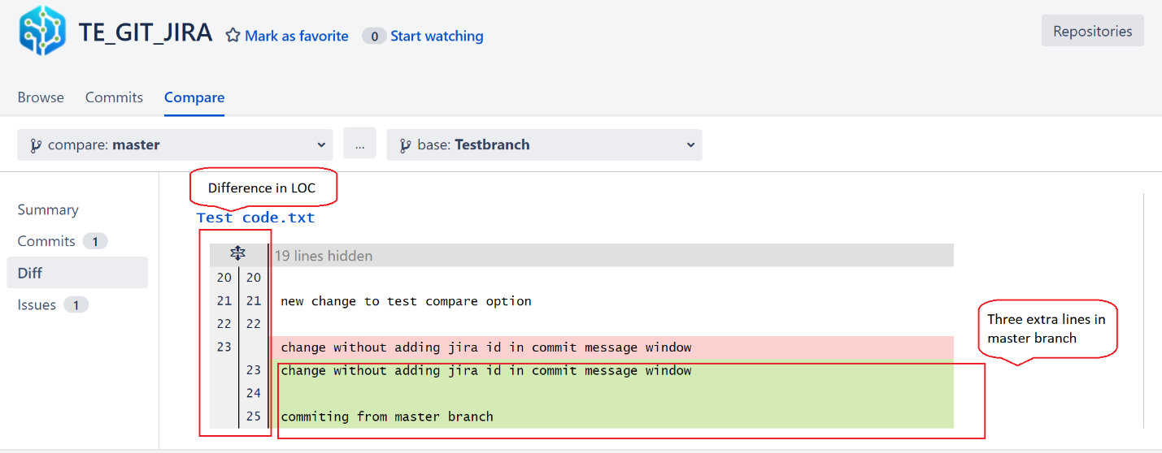

* Commit differences are visible in “Commits” tab.

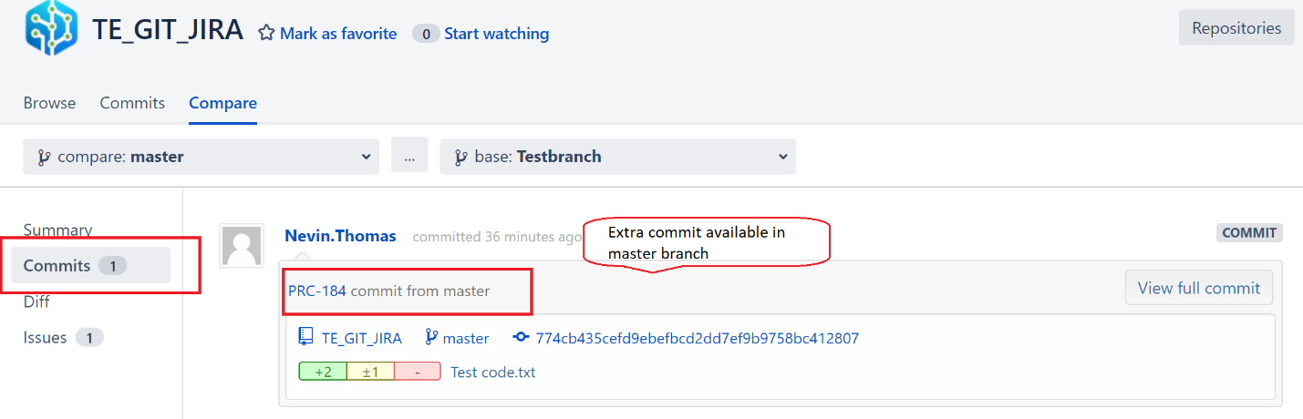

## Jira User Information Card

Git commits done by a JIRA user can be seen using “Activity” option.

All the JIRA & GIT commit activities can be visible in this window.

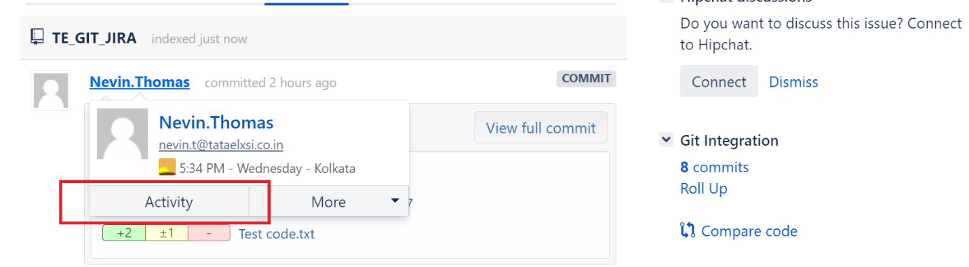

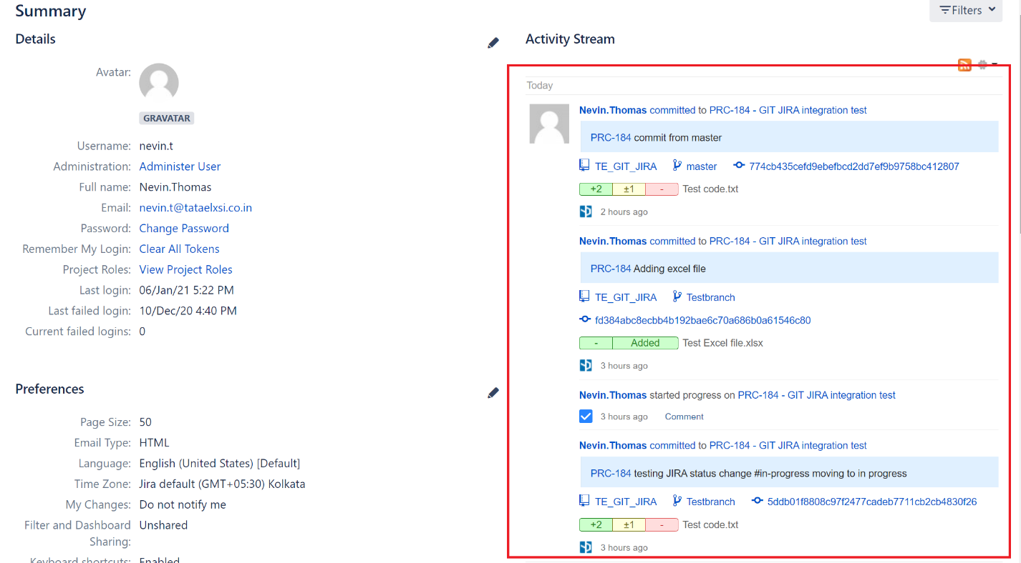

## Git Roll Up

* The “Git Roll Up” tab shows the summary of Repository browser window.
* Repository browser window can be expanded in a new tab as shown below.

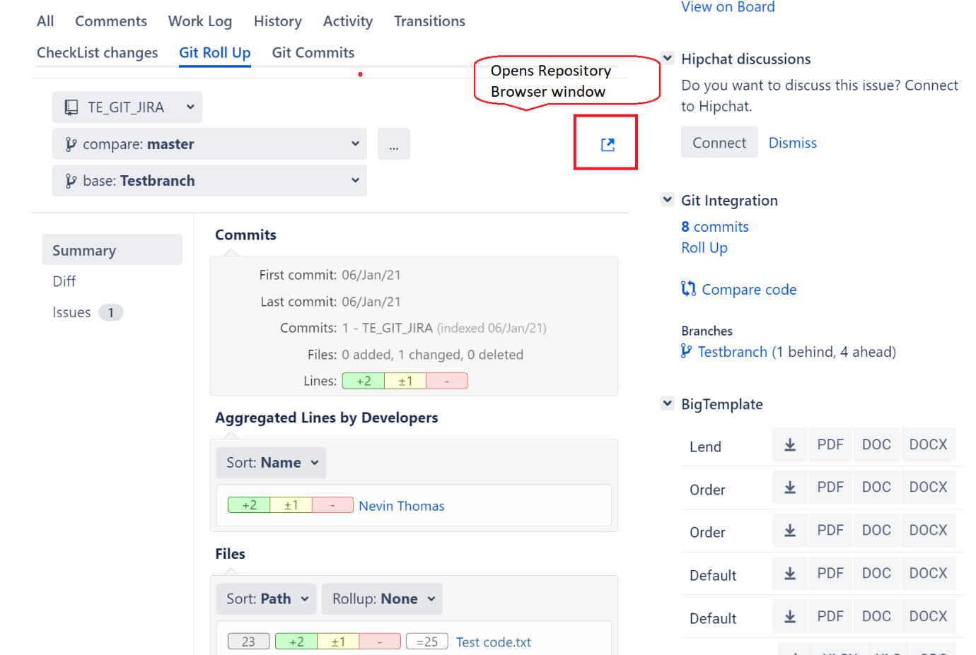

## Commit Email Notification

* A person watching the repository using the below option, is able to get email notification for all the commits.

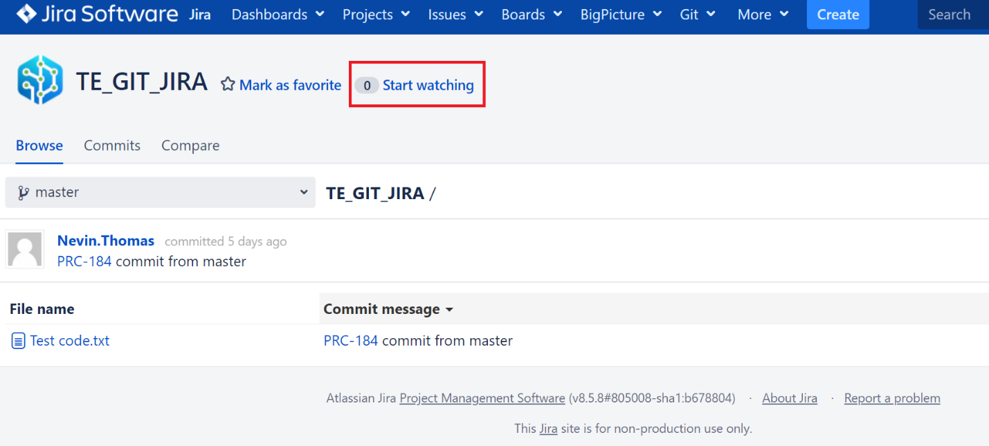

## Access Management

“View development tools” permission need to be enabled for the user group as per the permission scheme to access the Git plugin options.

“View development tools” permission can be restricted for a project permission scheme using any of the below options.

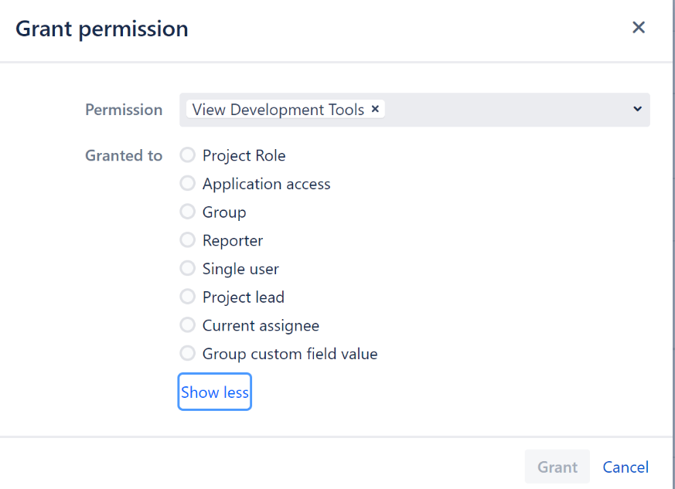

E.g.: If “View development tools” permission is available only for “Developer” group of a project, users’ other group won’t be able to access Git plugin options.

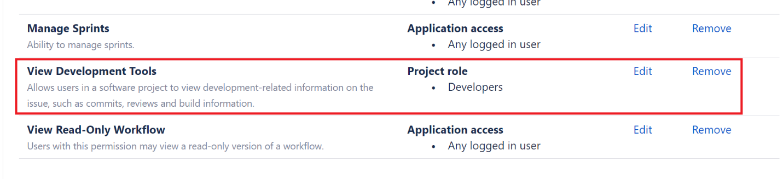

Users in “Tester” group will not have access to Git plugin.

### Git Repository Access Management

Repository access can be restricted to JIRA project from repository settings page.

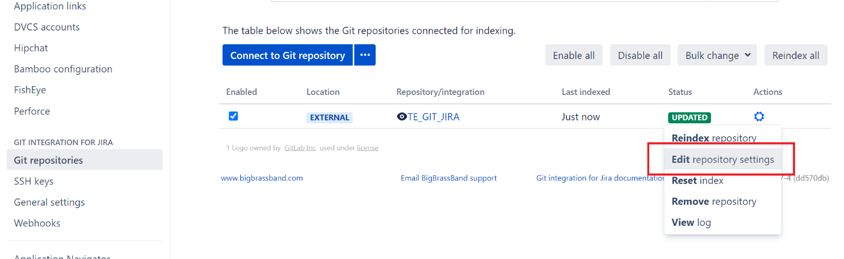

* **Case1:** Repository access restricted to Project B users using “Project Permissions” option:

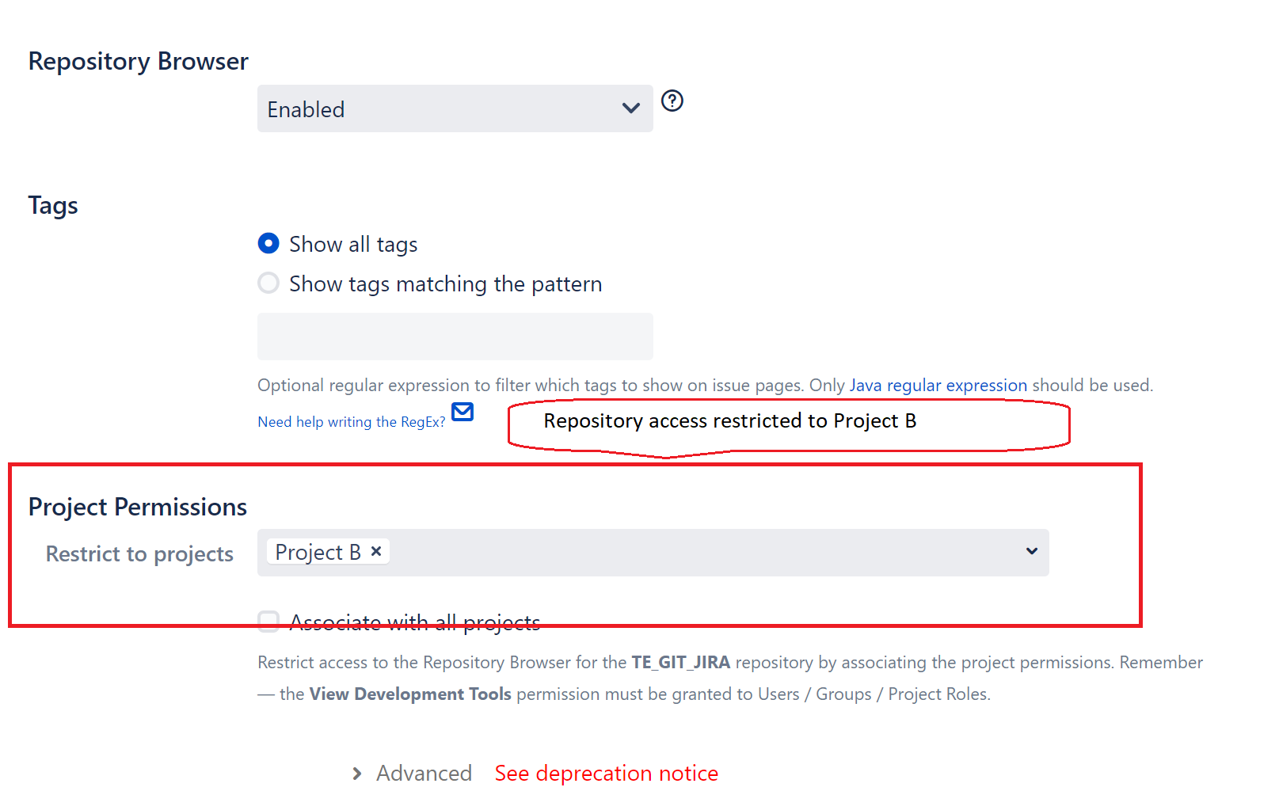

User in Project C does not have access to the Git plugin access is able to see the commits & file contents

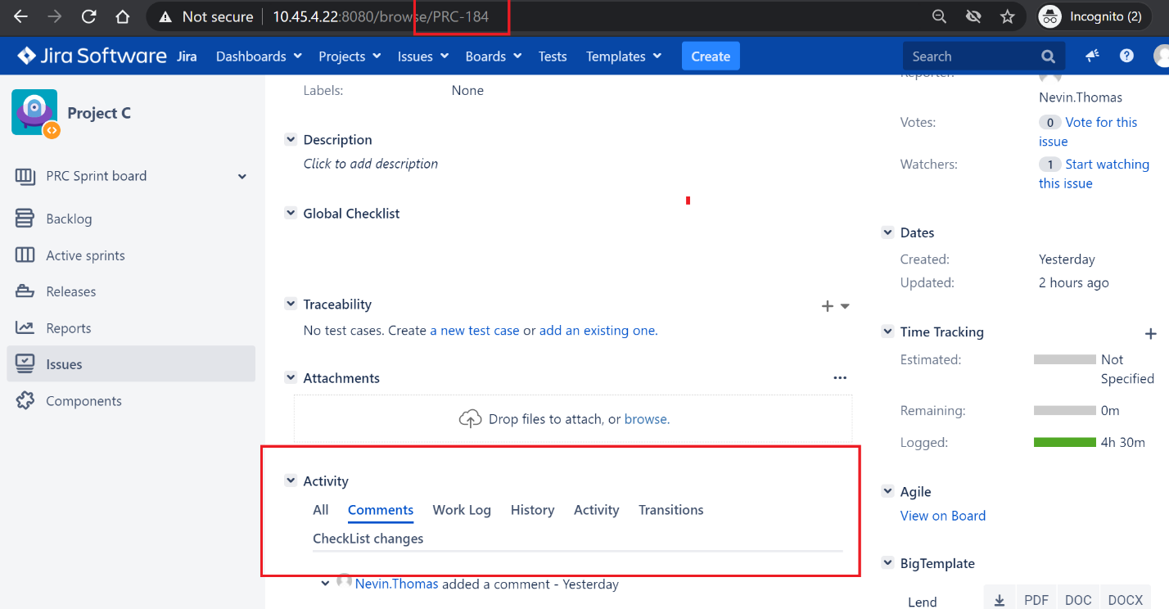

* **Case2:** Repository access also provided to Project C in addition to Project B users.

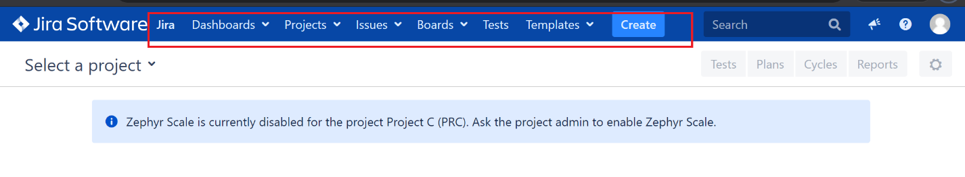

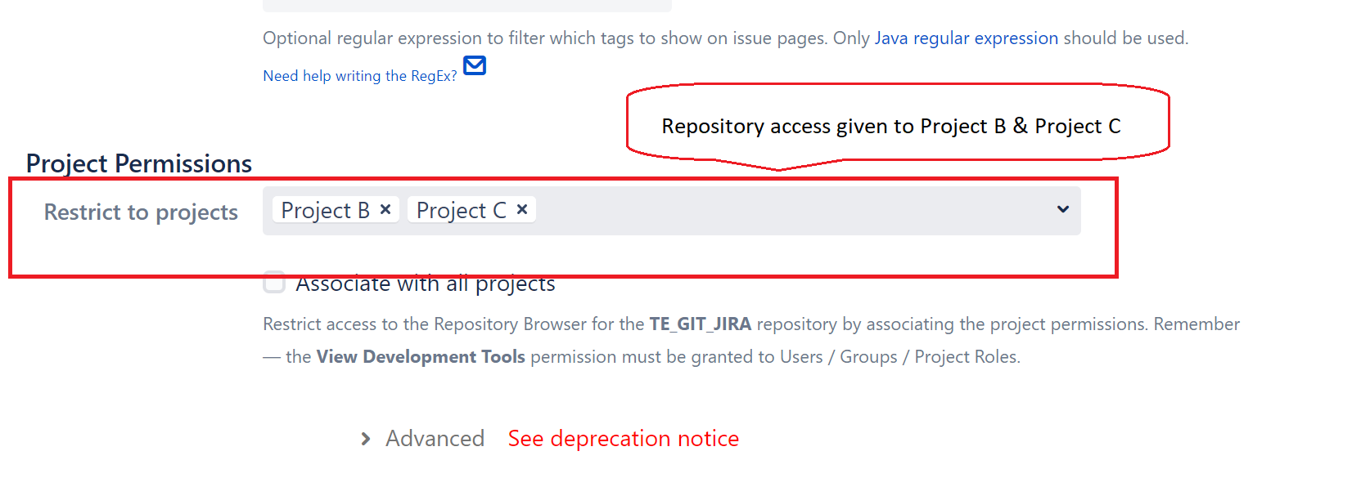

User in Project C now gets the Git plugin access & is able to see the commits & file contents.

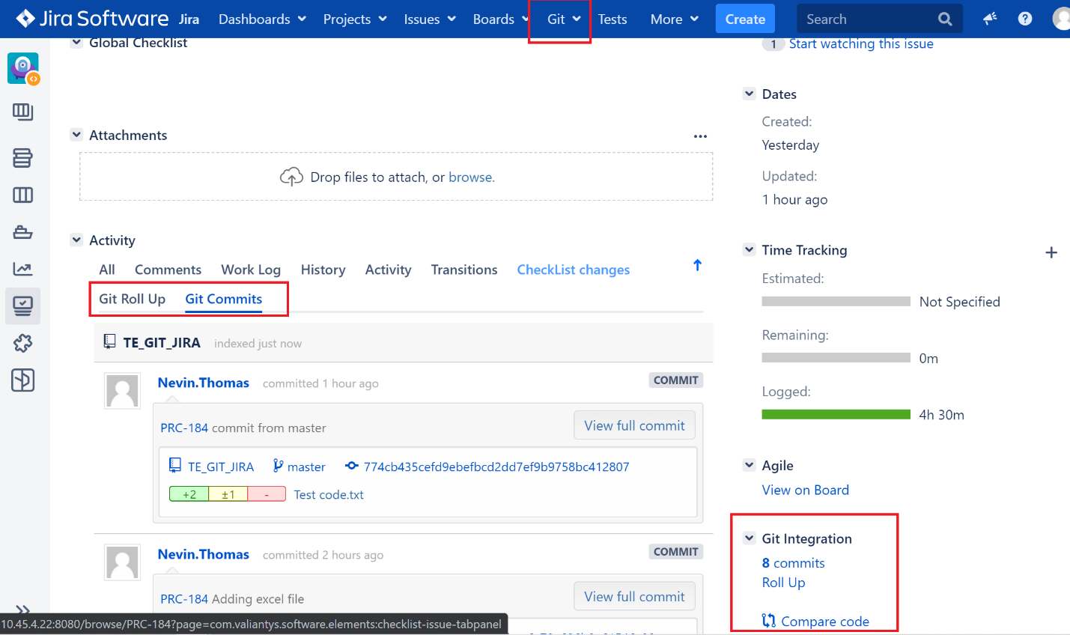

* **Case3:** User without access to Project C was able to view all the commits & file contents by accessing the Project C JIRA ticket, when “View development tools” access was granted to all logged in users.

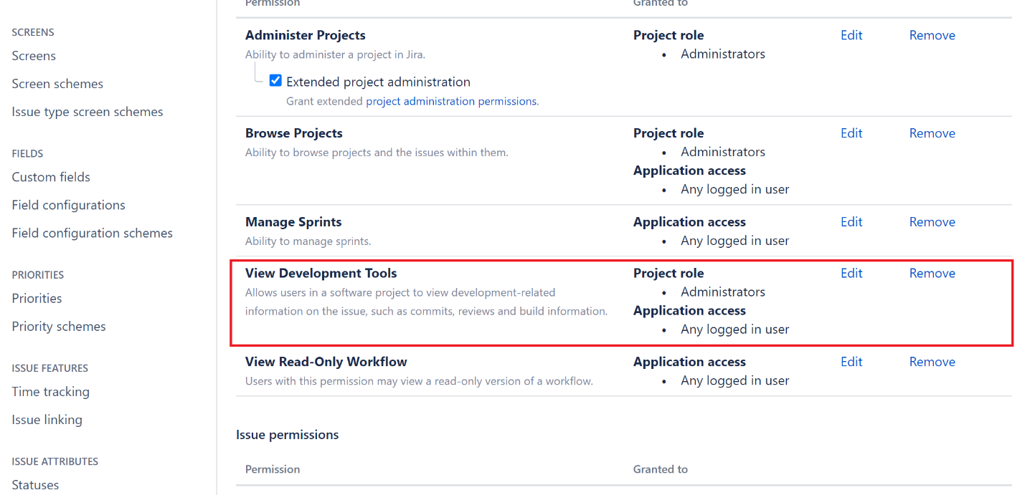

“View development tools” access should not be granted to all logged in users. If done so, the git commits details linked with JIRA tickets is exposed to all users.

## Features not supported in Gerrit

The below highlighted options are not possible in case of integration with Gerrit.

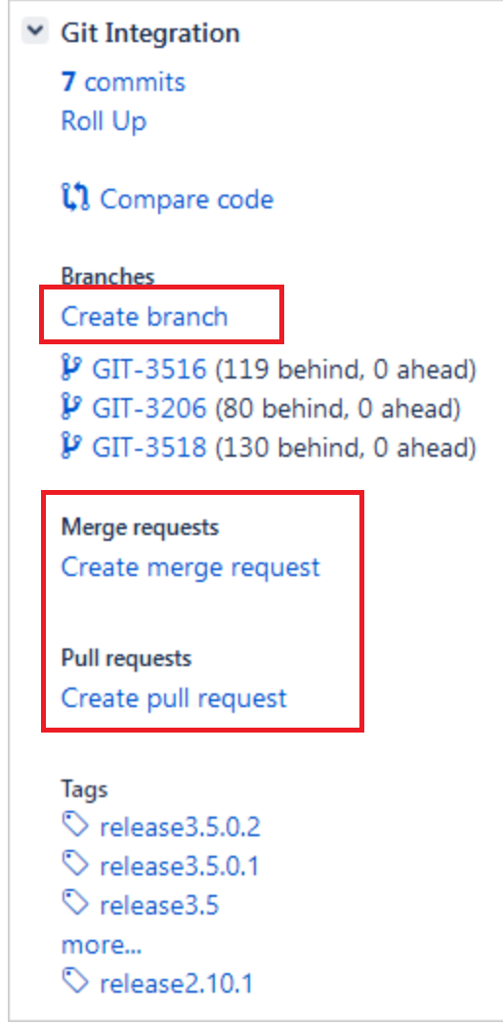

GitHub, Bitbucket etc. supports these features.

### 